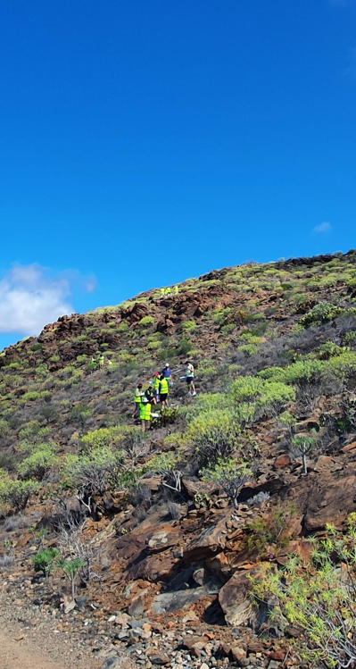

Fieldwork Risk Assessment
Pairs and Small Groups

School of Natural Sciences
Trinity College Dublin

https://naturalscience.tcd.ie/

Fieldwork Risk Assessment for Pairs or Small Groups

Data Security Statement
The personal data collected on risk assessment forms are being requested by The School of Natural Sciences, Trinity College Dublin (TCD) for the purpose of establishing contact details for the researcher and identifying a contactable person in the event of an emergency when the researcher is working in laboratories or away from the TCD campus. These data may be accessed by the Head of Discipline, Project Supervisor, Discipline Safety Officer, Chief Technical Officer or Discipline Technical Officer for contacting the student or researcher or to contact the emergency contact person in the event of an emergency. Your data will only be used for these purposes and will not be released to other parties without your permission, except as permitted by law. You have the right to access your own personal data which you supply here and the right to rectify those data. When submitted, this document will be stored securely on OneDrive at TCD. Your data will be retained until the laboratory work or fieldwork is complete. The information provided will be securely disposed of when the related period of work has been completed.

Please get permission from your contact person for the use of their name and phone number.

Please read the guidance notes fully before completing all sections of this form.

Date: |  | Assessed By: |  | Review Date:
Contact | Email: Mobile: |  |  | Review Date:

- Location and Date of Fieldwork
Location(s) | Date(s)

- Travel Plan and Accommodation
- Details of Fieldwork Activities
- Details of Environment(s)

- Who Will Be At Risk?

- Hazards, Risks and Controls (add additional rows if required)
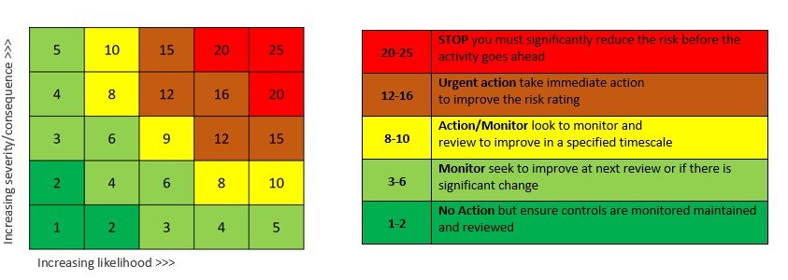

Geographical, Equipment and Field Location Hazards (add additional rows if required) : e.g. proximity to water, early/late sampling, mountains

Name/Location: Pre-controls Controls: Post-controls
(GPS co-ordinates) rating: rating:
Click here to enter hazard. | Choose a value. | List controls. | Choose a value.
Click here to enter hazard. | Choose a value. | List controls. | Choose a value.
Click here to enter hazard. | Choose a value. | List controls. | Choose a value.
Click here to enter hazard. | Choose a value. | List controls. | Choose a value.
Click here to enter hazard. | Choose a value. | List controls. | Choose a value.
Click here to enter hazard. | Choose a value. | List controls. | Choose a value.
Click here to enter hazard. | Choose a value. | List controls. | Choose a value.
Click here to enter hazard. | Choose a value. | List controls. | Choose a value.
Click here to enter hazard. | Choose a value. | List controls. | Choose a value.
Click here to enter hazard. | Choose a value. | List controls. | Choose a value.

Chemical Hazards (add additional rows if required): e.g. ethanol, hydrogen peroxide, dry ice
Name | CAS  No. | OELV | Quantity | Conc. | Labels (Tick all that apply) | Pre-controls  rating | Controls | Post-controls  rating
Chemical Name | Enter No. | Exposure Limit Value | In g/Kg or mls/L | Percentage or molarity |  | Choose a value. | List controls. | Choose a value.
  ☐ | 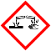 | ☐ |  | ☐ |  | ☐ | 
  ☐ |  | ☐ | 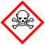 | ☐ |  | ☐ | 
  ☐ | 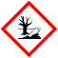
Chemical Name | Enter No. | Exposure Limit Value | In g/Kg or mls/L | Percentage or molarity |  | Choose a value. | List controls. | Choose a value.
  ☐ |  | ☐ |  | ☐ |  | ☐
  ☐ |  | ☐ |  | ☐ |  | ☐
  ☐

- Reporting systems for fieldwork
Each fieldworker should have a named contact person.
The contact person must be informed, before each day’s work, of:
- the field worker’s itinerary for the day
- the planned time of return at the end of the day.

The worker must phone or text (or radio) the contact person at or before the return/completion time, either:
- to confirm safe return, or
- to inform of any delay

If there is a delay, the worker must continue to keep the contact person informed until safe return can be reported.

Procedure to Follow Should Reporting System Fail
If the field worker does not make contact within an agreed period after the planned time of return, the contact person is to attempt to contact the field worker. If this fails:
- Contact person is to contact emergency services (dial 999 or 112, or number of nearest Garda station).
- Contact person is to contact Supervisor or PI. If the Supervisor is unavailable, the contact person is to contact the Head of Discipline.

Fieldworker, Contact Person and Supervisor Details

Field Workers (add more workers if required):

Name: Enter fieldworker’s name
Phone: Mobile only
Address(es) during fieldwork: Click here to enter address
Phone number at fieldwork address: Mobile or landline

Name: Enter fieldworker’s name
Phone: Mobile only
Address(es) during fieldwork: Click here to enter address
Phone number at fieldwork address: Mobile or landline

Contact (add more contacts as necessary):
First Fieldworker’s Contact
Name: Contact’s Full name
Contact’s relationship to fieldworker: Click or tap here to enter text.
Phone: Mobile or landline

Second Fieldworker’s Contact
Name: Contact’s Full name
Contact’s relationship to fieldworker: Click or tap here to enter text.
Phone: Mobile or landline

I (supervisor/PI) have read and agree to the contact plans outlined above.
Yes Date: Click here to enter a date.

I (first fieldworker) confirm that I have provided my contact with all the relevant information and my supervisor’s contact information.
Please choose Date: Click here to enter a date.

I (second fieldworker) confirm that I have provided my contact with all the relevant information and my supervisor’s contact information.
Please choose Date: Click here to enter a date.

- Additional Information

Approval
I confirm that I have read the School of Natural Sciences’ Fieldwork Safety Manual, Risk Assessment Guidance Notes and Checklists before carrying out this risk assessment and that the information provided conforms to the guidelines detailed in these documents. Tick staff or student box as appropriate then print your name, sign, and date. Electronic signatures* are acceptable

Assessed By | Print Name | Sign* | Date
Staff ☐ Student ☐
Approved By
Supervisor
Head of Discipline**

*An electronic signature is required. Do not type your name in this box or apply handwriting font. In accordance with Regulation (EU) No 910/2014) and Section 22 of the Electronic Commerce Act 2000 an electronic signature must meet the following requirements (a) it is uniquely linked to the signatory; (b) it is capable of identifying the signatory; (c) it is created using means that are under the signatory’s sole control; and (d) it is linked to other electronic data in such a way that any alteration to the said data can be detected.

**Only where the activities are regarded as medium or high risk at the supervisor/PI’s discretion or where the fieldwork will take place outside of Ireland.

Sign-off sheet
This should be signed by anyone other than the assessor or approval signatories who will be participating in this fieldwork. Do not enter names or signatures until the participants have read the risk assessment. This can be completed manually on a printed copy on the day of the fieldwork if required. For large groups you can request additional sign-off sheets from the Discipline Safety Officer. Include all participants and ensure everyone involved has read the risk assessment before the fieldwork begins. To comply with GDPR regulations, any hard copies in your possession should be securely destroyed when the fieldwork is completed.

Declaration: I have read the risk assessment for this field trip. I understand and will abide by the controls measures and health and safety requirements set out in this document to ensure I work safely and consider the health, safety and welfare of others.

Name (Print name) | Signature | Date

