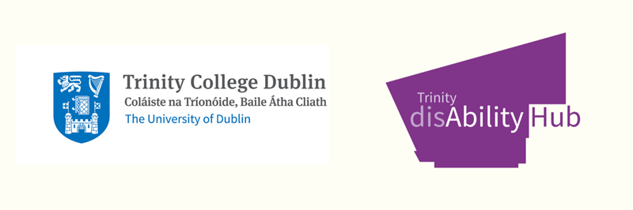

Trinity disAbility Service

Consent to Share Information with Parent/Guardian (2025 Version)
The Trinity disAbility Service (DS) recognises that all students at Trinity College Dublin are adults. The relationship regarding disability supports is between the student and the University. In exceptional circumstances, the DS may communicate with a parent or guardian, but only where the student has provided explicit, informed consent. This ensures compliance with the Data Protection Acts 1988–2018 and the EU General Data Protection Regulation 2016 (GDPR).

Purpose of this Form
This form allows a student to give consent for the DS to share relevant information with a named parent or guardian for a single meeting, phone call, or email exchange. A separate form must be completed for each new instance of communication. Consent automatically expires once the agreed communication has taken place. All communications with third parties under this procedure will be shared with the student once the communication is completed, and it is expected that the student will be directly involved in any meetings or email correspondence.

Student Details
Full Name: ____________________________________________
Student Number: _________________________________________
Course: ________________________________________________
Year: _________________________________________________

Request for Communication
☐ Phone Call ☐ Email ☐ Meeting
Proposed Date of Communication: ___________________________
Name(s) of Parent/Guardian to be included: ___________________________
Reason for Request / Topic to be Discussed:
____________________________________________________________________
____________________________________________________________________

Consent and Declaration
By signing below, I confirm that I am an adult student of Trinity College Dublin. I understand that my relationship with the Disability Service is confidential and that the Service will only share information I have consented to share. I give permission for the DS to communicate with the named parent/guardian regarding the issue described above for this single communication instance only.
I understand that this consent will expire once the specified communication has taken place, and that I may withdraw my consent at any time by notifying the Disability Service in writing.

Data Protection and Retention
The information provided in this form will be used solely for the purpose of managing this communication. It will be stored securely in compliance with data protection legislation and College policy, and retained for one year after submission before being securely deleted. For further information, please see the Disability Service Privacy Notice at: https://www.tcd.ie/disability/privacy-notice/

Signatures
Student Signature (Digital or Typed): _______________________________
Date: ___________________________
Disability Officer Signature: _______________________________
Date: ___________________________
Trinity disAbility Service | Printing House Square | Trinity College Dublin
Email: askds@tcd.ie | Website: www.tcd.ie/disability
Version 4.0 – December 2025

