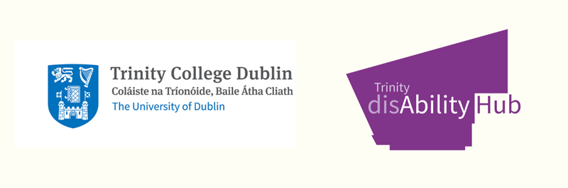

Speech: Launch of Trinity disAbility Service—Journey 2000–2025
Good evening everyone—Provost, colleagues, students, alumni, partners, and friends.
Tonight we’re doing two things at once: we’re celebrating a story, and we’re turning a page. The story is the one captured in this booklet—Trinity disAbility Service: Journey 2000–2025 and the new page is what we choose to do next with that story.
When I look back over these 25 years, what stands out most is how a small idea became a movement. In 1995 Trinity established a Special Needs Committee a modest but vital first step that said, “we’re going to do this properly.”
By 2000, the Service was formally created—one office, one full-time post, and 64 students registered for support at the turn of the millennium. Today that number is close to 3,000. That isn’t just growth; it’s culture change. It means more people felt welcome, believed they belonged, and chose Trinity.
Very early, we realised that inclusion can’t rely on heroic individual fixes; it has to be designed in. In 2002 we created the LENS, Learning and Educational Needs Summary, so that a student’s needs didn’t have to be explained again and again, and staff had a clear, professional, consistent way to act. Many students call it their “disability passport.” That idea travelled—beyond modules, beyond schools, beyond Trinity.
We’ve also learned that access is as physical as it is cultural. The accessible pathways through Front Square in 2010 weren’t just granite; they were a statement of intent about desire lines, dignity, and the right to be in the heart of Trinity, not skirting its edges. Those paths said, “this campus is for you.”
Policy matters too. In 2009, the DARE scheme brought a unified national route into higher education for disabled students, shaped in part by work led from this community. And in 2018, Trinity approved Ireland’s first university Reasonable Accommodation Policy setting a sectoral standard for how we identify, document, and implement support. Frameworks like these turn goodwill into guarantees.
Spaces matter. In 2022 we opened the Trinity disAbility Hub in Printing House Square. It’s more than a building; it’s a working symbol of the values in this booklet—co-creation, visibility, and empowerment home to six meeting rooms named for disabled Trinity leaders whose achievements are literally built into our walls.
And we keep innovating. In 2023 we launched the TCD Sense Map designed with neurodivergent interns and an engineering graduate—so people can navigate campus not only by buildings, but by sensory reality. In 2024 we expanded user-led auditing with the ULAA-Tool and grew inclusive internships across the university. These are the kinds of practical tools that change daily experience, not just policy documents.
All of this sits alongside a sustainability charter that changed how we operate, paperless by design, no desk bins, digital notebooks because inclusion and sustainability belong together. They’re both about stewardship and care.
But the most important line in this whole story is the one that runs through our students: students who asked why they couldn’t go to the Pav “like everyone else,” and then helped make sure everyone could; students who designed logos, mapped sensory routes, audited spaces, and led campaigns; students who became colleagues and partners. That’s the heart of this journey.
So what’s on the next page?
First, scale what works. In 2025 we’ve been putting the plumbing in place: a person-centred CRM, school-level Power BI dashboards, and alignment between SITS and Blackboard Ultra so that accommodations flow with learning and assessment. It’s not glamorous but it’s how good practice becomes standard practice.
Second, grow leadership and employment. The Inclusive Internship Programme is now college-wide; the Trinity Ability co_op is recognised as a Disabled Persons Organisation; and our Leaders’ Project keeps reminding us that talent is everywhere when the system is fair. We’ll keep opening doors, placements, mentoring, and an Employability Passport so every student can graduate with confidence.
Third, transform the estate with a Universal Access plan—five years of user-led improvements—so that teaching, learning, and movement through Trinity feel seamless. We will have a dedicated project manager and a roadmap to act on what students have already told us through ULAA.
As the Provost launches her first strategic plan tomorrow—Thrive—embedding inclusion through people, purpose, and place, we set our course accordingly. We’ll anchor all of this in a new Access & disAbility Action Plan, 2025–2030, our promise to “leave no one behind.” The plan introduces the Trinity Inclusive Integrated Model (TIIM) and a “Fourth Space” where disabled students and staff are not just participants in services, but co-creators of policy, research, and culture across the university. That’s the shift: from support for to leadership with.
Our four pillars keep us honest:
- disAbled Partnerships & Leadership: embedding lived experience in governance and design.
- Enhanced Employability: targeted routes into meaningful work and leadership.
- Research, Innovation & the Hub: a centre of excellence with global reach.
- Embedding Access & Inclusion: universal design—physical, digital, and pedagogical—everywhere.
But plans are only as good as the people who deliver them. So let me say a few thank-yous.
To the students, past and present, who challenged us, partnered with us, and trusted us: thank you for your courage and your candour.
To colleagues across Schools, Student Services, TAP, Estates & Facilities, the Library, Academic Registry, Careers, and more—thank you for proving, again and again, that inclusion is a team sport.
To our champions in leadership—Provost and senior colleagues—thank you for the policy decisions, the funding, and the permission structures that made change possible.
To the Director of Student Services: your leadership has helped embed disability inclusion as a thread running through everything we do, extending our reach and impact—thank you.
To our alumni and external partners, who have opened internships, shared expertise, and widened the path beyond graduation—thank you.
And to the disAbility Service team (past and present): you are the reason this booklet has so many pages.
Let me finish with a simple idea that the booklet expresses again and again, in different ways: inclusion is not an add-on. It’s infrastructure. When we build it in, everyone moves more freely across the Square, through our systems, and into their futures. The last 25 years proved that. The next five will define it.
This book is our memory. Our action plan is our promise. And our students are our purpose.
Here’s to the next chapter, written together, with ability, inclusion, and belonging at its heart.
Go raibh míle maith agaibh.

