



School Name

Title of Handbook AY XX/XX

TABLE OF CONTENTS
- General Regulations 1
- Student Services 1
  - Academic Support 7
  - Health and Wellbeing Support 7
  - Getting Involved 7
  - Financial Support 8
  - Administrative Support 8
  - Your Tutor 8
  - Postgraduate Advisory Service 9
  - The Academic Registry 10
  - Information on key campus locations 10
  - Student Representation and Governance 11
  - Careers Information 11
- Academic Writing 11
  - The Use and Referencing of Generative AI 11
  - Academic Integrity and Referencing Guide 11
  - Research Ethics 12
- General Information 13
  - Emergency Procedure 13
  - Health and Safety Statements 13
  - Data Protection 13
  - Explanation of ECTS Weighting 13
  - Links to Further University Policies and Procedures 14

Trinity Visual Identity Guidelines
Accessible Information Policy

Note: This document is a template for Schools/Disciplines. There may be additions/amendments appropriate to the needs of an individual School that reflect the local regulations of the School/Discipline and are in accordance with the Calendar.

GENERAL REGULATIONS
Standard Text: In the event of any conflict or inconsistency between the General Regulations published in the University Calendar and information contained in programme or local handbooks, the provisions of the General Regulations in the Calendar will prevail.

Reference/Source Calendar
Calendar Part II, Part B: General Regulations and Information

Calendar Part III, Section 1: General Academic Regulations

- STUDENT SERVICES
Student Services has developed the handbook (embedded below) outlining the support services provided to undergraduate and postgraduate students. The handbook and further information is available from their website and in the Student Services Handbook. School/Department Handbooks can provide a link to the PDF or embed the PDF within the Handbook itself.

Reference/Source: Student Supports & Services

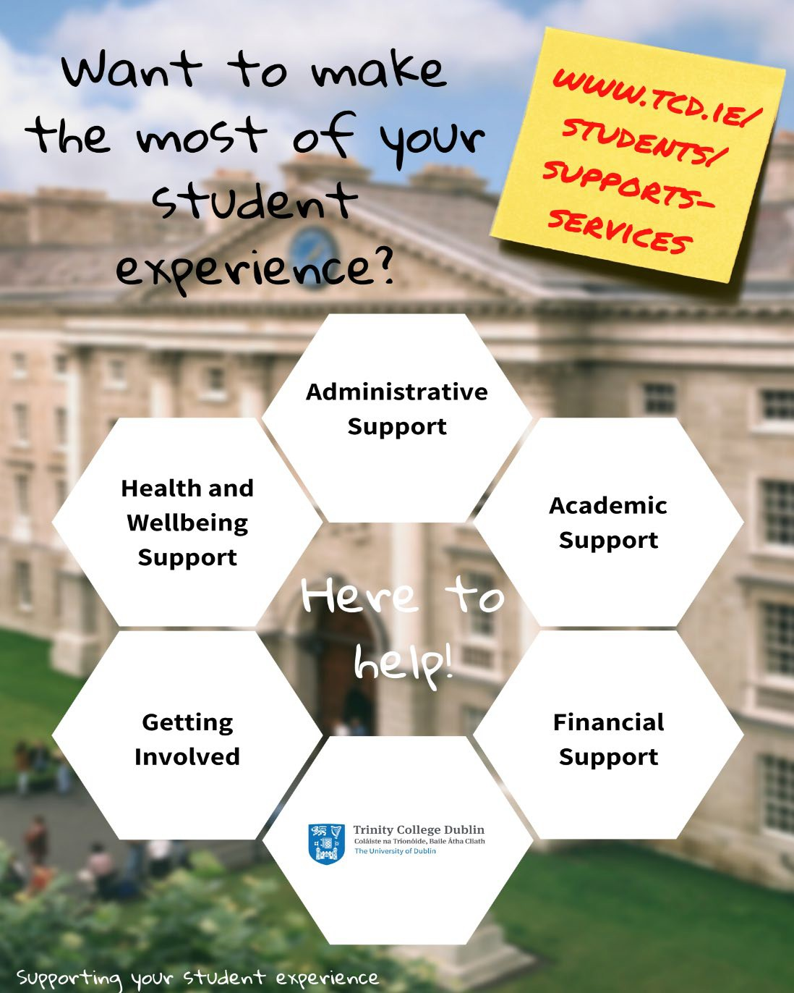

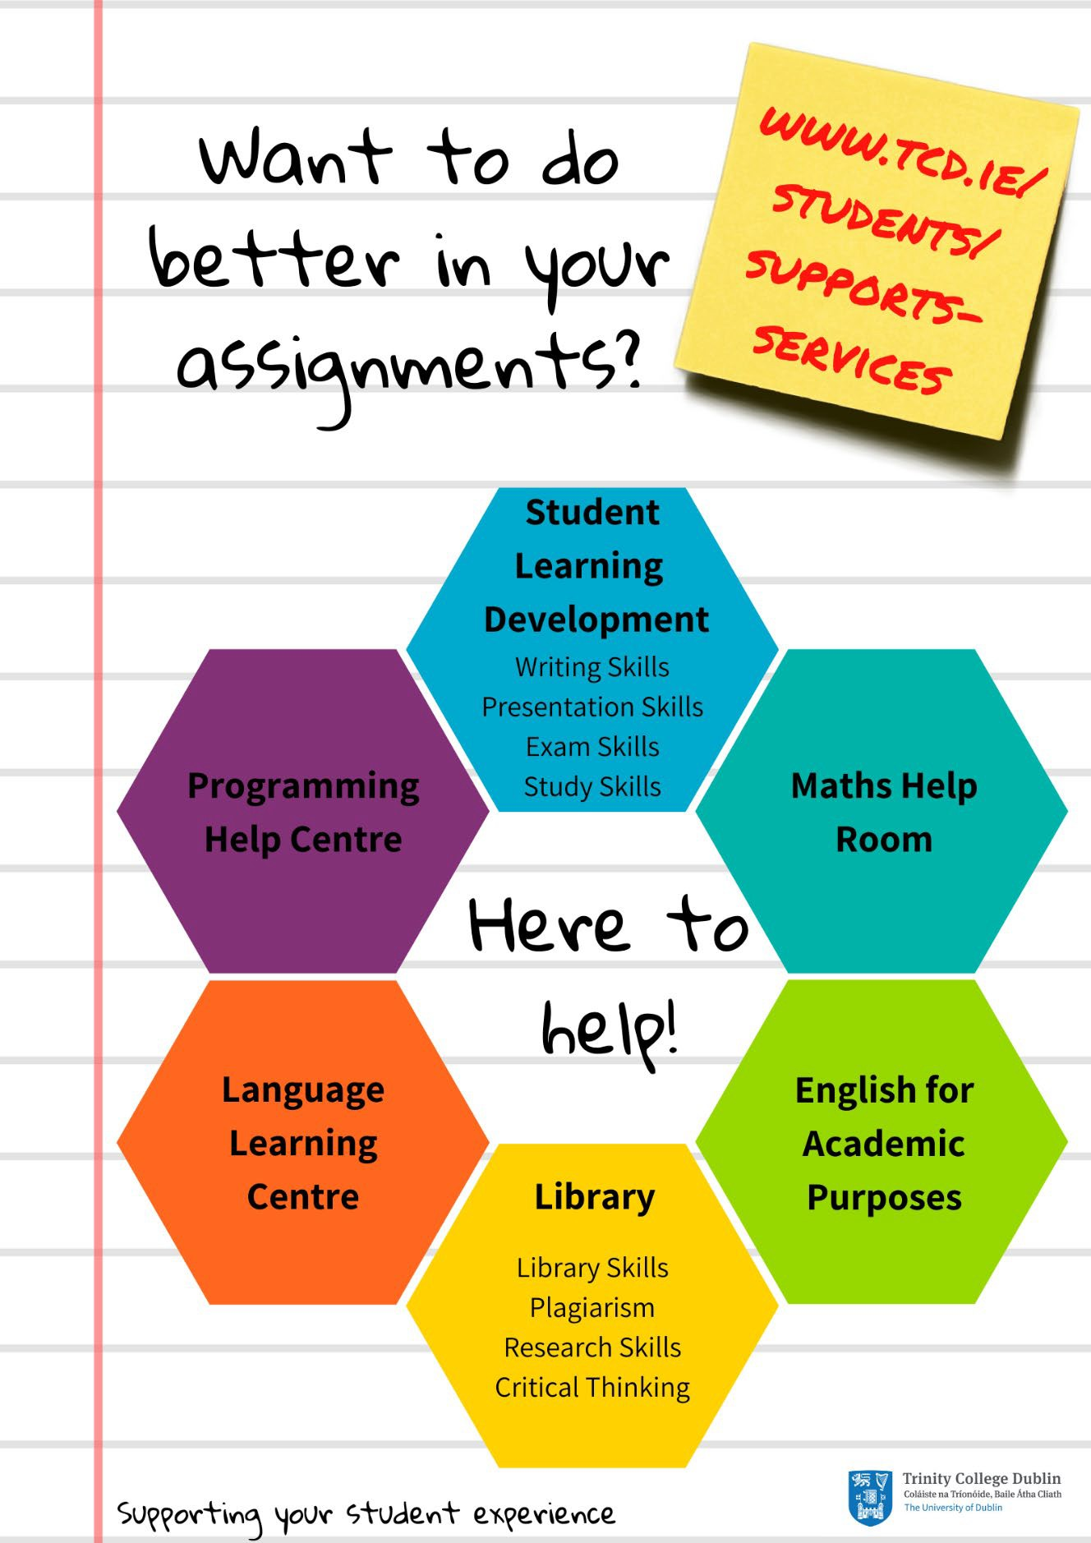

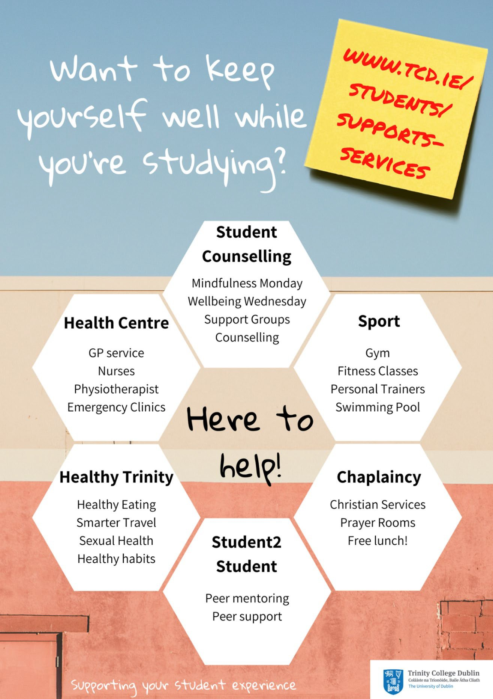



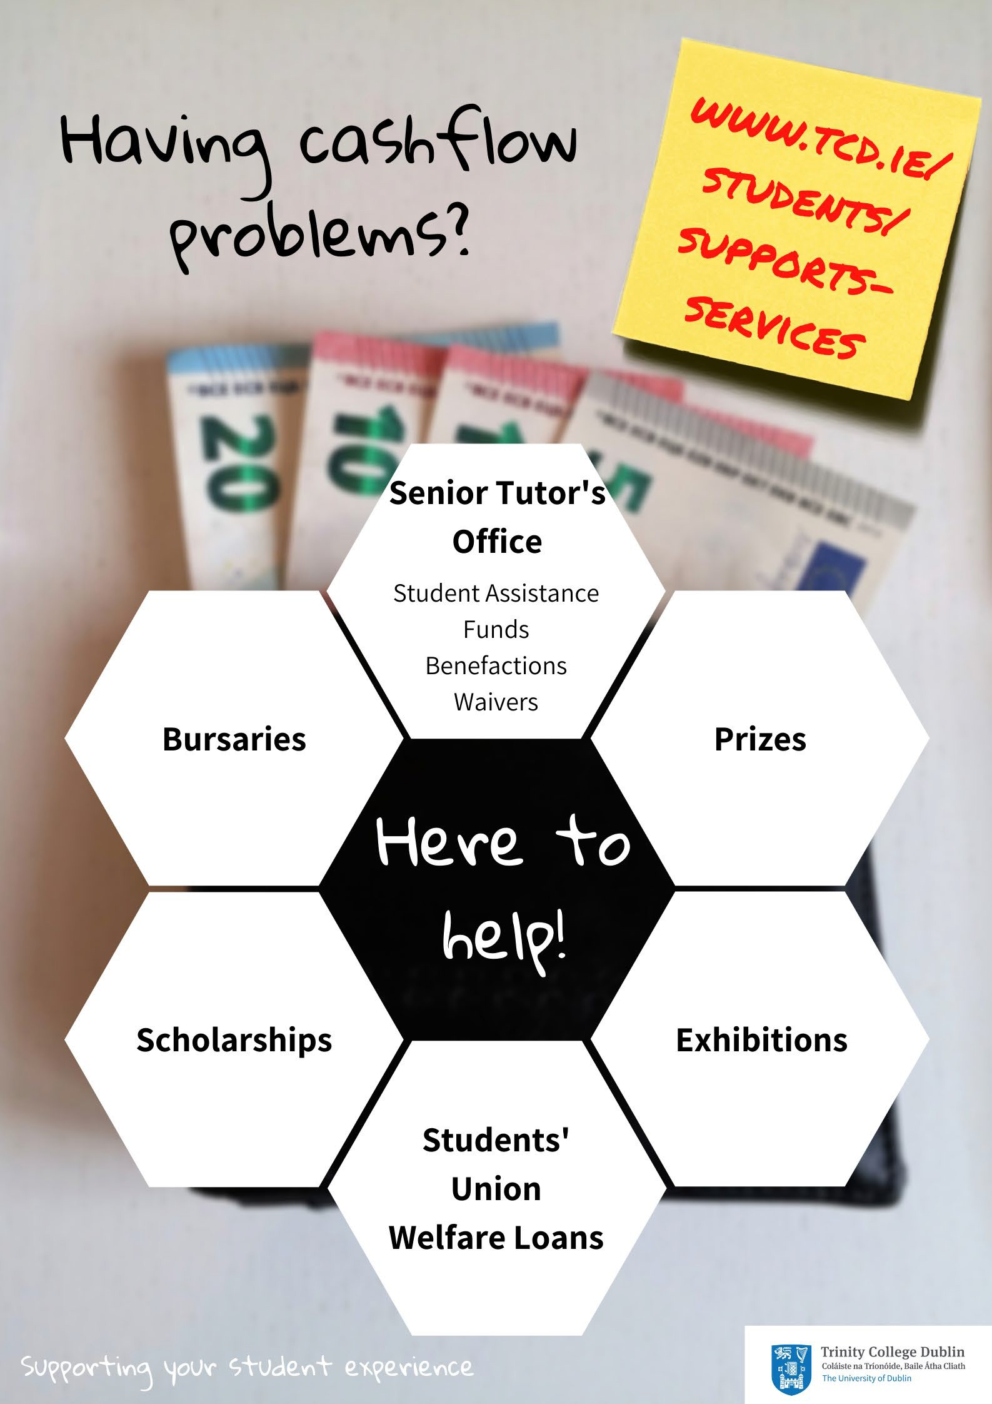

Student Learning Development | http://student-learning.tcd.ie/
The Library | http://www.tcd.ie/library/
Maths Help Room | http://maths.tcd.ie/outreach/helproom/
Undergraduate Programming Centre | https://teaching.scss.tcd.ie/general-information/ugpc/
Language Learning Centre | http://www.tcd.ie/slscs/clcs/llc/
Centre for English Language Learning and Teaching | https://www.tcd.ie/slscs/english/
Disability Service | http://www.tcd.ie/disability/
Careers Service | http://www.tcd.ie/Careers/

  - Health and Wellbeing Support

Student Counselling | http://www.tcd.ie/Student_Counselling/
Health Centre | http://www.tcd.ie/collegehealth/
Sport | http://www.tcd.ie/Sport/
Healthy Trinity | http://www.tcd.ie/healthytrinity/
Student2Student | http://student2student.tcd.ie/
Chaplaincy | http://www.tcd.ie/Chaplaincy/

  - Getting Involved

Students’ Union | http://www.tcdsu.org/
Clubs | http://www.tcd.ie/Sport/student-sport/
Societies | http://trinitysocieties.ie/
Volunteering | http://www.tcd.ie/civicengagement/
Entrepreneurship/Portal | https://www.tcd.ie/portal/
Global Room | http://www.tcd.ie/study/international/trinity- life/global-room/

Senior Tutor’s Office* | http://www.tcd.ie/seniortutor/students/undergraduate/financial-assistance/
Students’ Union Welfare Loans | https://www.tcdsu.org/welfare-equality/welfare-resources
Bursaries/Prizes (Undergraduate) | http://www.tcd.ie/calendar/undergraduate-studies/ (Part D: 11 - Prizes and other awards)
Bursaries/Prizes (Postgraduate) | https://www.tcd.ie/calendar/graduate-studies- higher-degrees/  (Section XI: Postgraduate Awards and Travel Funds)
Exhibitions | http://www.tcd.ie/calendar/undergraduate-studies/ (Part D: 8 - Entrance Awards)
Scholarships | http://www.tcd.ie/study/undergraduate/scholarships  -funding/
*Remember, you can ask your Tutor for advice and guidance about anything and they will point you in the right direction

Administrative Support

Your Tutor | http://www.tcd.ie/seniortutor/
Postgraduate Advisory Service | http://www.tcd.ie/seniortutor/students/postgraduate
Academic Registry | http://www.tcd.ie/academicregistry/

  - Your Tutor
All registered full-degree undergraduate students are allocated a Tutor when starting in College. Your Tutor is a member of academic staff who is appointed to look after the general welfare and development of all students in their care.

You should see your Tutor whenever you have a question or are worried or concerned about any aspect of College life or your personal life, in particular if it is affecting your academic work. Everything you say to your Tutor is in strict confidence. Unless you give them permission to do so, they will not give any information to anybody else, whether inside College or outside (not to your parents/family for example). Your Tutor can help you only if they know you are facing difficulties, so if you are worried about anything go and see your Tutor before things get out of hand. Whilst your Tutor may not be able to solve the underlying problem, they can help you find the best way to limit the impact of your situation on your College work. Tutors can help with academic advice, changing course, withdrawing from College, exam regulations, financial assistance and personal advice.

Postgraduate Advisory Service
The Postgraduate Advisory Service offers free, independent, and confidential support, guidance and advocacy to registered postgraduate students. They are here to provide support on any matter that may impact upon your time as a postgraduate at Trinity.
Some of the most common issues students come to PAS to discuss include: study-related stress or worry; concerns about academic progress; supervisor-relationship concerns; extensions and going off-books; queries regarding regulations and academic appeals; bullying; plagiarism and disciplinary cases, financial assistance.

The Academic Registry
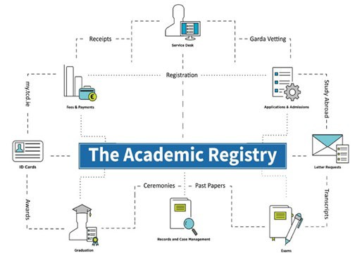

  - Information on key campus locations
You may include information on key campus locations relevant to your School’s students. Click or tap here to enter text.

Reference/Source

Student Supports & Services

Interactive College Map

  - Student Representation and Governance
Information on the TCDSU student representation structures are available at the following links:

TCDSU

TCDSU Student Representation Overview

  - Careers Information
Information on Careers for your students Click or tap here to enter text.

References/Sources:

Trinity Careers Service

Careers - PG Focus

- ACADEMIC WRITING

3.1 The Use and Referencing of Generative AI
Include the following text:
Aligned with the College Statement on Artificial Intelligence and Generative AI in Teaching, Learning, Assessment & Research (2024), the use of GenAI is permitted unless otherwise stated. Where the output of GenAI is used to inform a student’s document or work output, this usage should be acknowledged and appropriately cited, as per Library guidelines on acknowledging and reference GenAI. From an academic integrity perspective, if a student generates content from a GenAI tool and submits it as his/her/their own work, it is considered plagiarism, which is defined as academic misconduct in accordance with College Academic Integrity Policy.
If the School wishes to put other restrictions in place around the use of Generative AI in particular modules, those restrictions must be explicitly stated in modules descriptions in the Blackboard VLE and/or in Programme Handbooks.

Reference/Source
College Statement on Artificial Intelligence and Generative AI in Teaching, Learning, Assessment and Research
Library guidelines on acknowledging and reference GenAI.

3.2 Academic Integrity and Referencing Guide

Standard Text to be copied from the Calendar with a link to the Academic Integrity Policy and the Statement of Principles on Integrity included.

A link to the Library Guidelines on Academic Integrity and a link to the coversheet declaration text for submitted assignments.

Should there be local policy on referencing or programme copy of the coversheet declaration, include relevant links and/or details to inform students.

Click or tap here to enter text.

Reference/Source

Calendar Part II, B: General Regulations & Information, ‘Academic Integrity’

Statement of Principles on Integrity

Academic Integrity Policy

Library Guides - Academic Integrity

Coversheet Declaration

  - Research Ethics
On relevant programmes, Schools should provide relevant links and information regarding good practice in research, as well as provide information on College and Faculty policies and procedures.
Click or tap here to enter text.

Research Ethics

Policy on Good Research Practice

Ethics Policy

- GENERAL INFORMATION
  - Emergency Procedure
In the event of an emergency, dial Security Services on Extension 1999

Security Services provide a 24-hour service to the College community, 365 days a year. They are the liaison to the Fire, Garda and Ambulance services and all staff and students are advised to always telephone Extension 1999 (+353 1 896 1999) in case of an emergency.
Should you require any emergency or rescue services on campus, you must contact Security Services. This includes chemical spills, personal injury or first aid assistance.

It is recommended that all students save at least one emergency contact in their phone under ICE (In Case of Emergency).
It is also recommended that students download the SafeZone app to access alerts for closures in inclement weather, etc.

Health and Safety Statements
Applicable information relating to health and safety in the classroom, laboratories, or other locations as relevant.
Click or tap here to enter text.

Data Protection
Information on Data Protection regarding your student data is available from:

Data Protection for Student Data

  - Explanation of ECTS Weighting
The European Credit Transfer and Accumulation System (ECTS) is an academic credit system based on the estimated student workload required to achieve the objectives of a module or programme of study. It is designed to enable academic recognition for periods of study, to facilitate student mobility and credit accumulation and transfer. The ECTS is the recommended credit system for higher education in Ireland and across the European Higher Education Area.
The ECTS weighting for a module is a measure of the student input or workload required for that module, based on factors such as the number of contact hours, the number and length of written or verbally presented assessment exercises, class preparation and private study time, laboratory classes, examinations, clinical attendance, professional training placements, and so on as appropriate. There is no intrinsic relationship between the credit volume of a module and its level of difficulty.
The European norm for full-time study over one academic year is 60 credits. Within Undergraduate courses 1 credit represents 20-25 hours estimated student input, so a 10-credit
module will be designed to require 200-250 hours of student input including class contact time, assessments and examinations. Within Postgraduate courses, 1 credit represents 25 hours estimated student input, so a 10-credit module will be designed to require 200-250 hours of student input including class contact time, assessments and examinations.
ECTS credits are awarded to a student only upon successful completion of the programme year. Progression from one year to the next is determined by the programme regulations. Students who fail a year of their programme will not obtain credit for that year even if they have passed certain component. Exceptions to this rule are one-year and part-year visiting students, who are awarded credit for individual modules successfully completed.
Reference/Source:

Description of ECTS for use in Course Handbooks

Links to Further University Policies and Procedures
The following are links of where to find further information on University regulations, policies, and procedures that you may find useful as a student:

All Academic Policies

Student Complaints Procedure

Dignity & Respect Policy

Equality Policy

